

**FINAL REPORT**

**ONLINE SHOPPING CART**

**SUBMITTED BY:**

**Name: Venganti Sairaj**

**Reg.no : 11706658**

**INTRODUCTION:**

The project Kidsor has been developed on HTML, NODEJS, CSS, Java Script, EXPRESSJS, and MONGODB. An online shopping store which will allow formal and informal merchants in developing countries to advertise and sell their good on the internet. This would permit rural communities to make their wares available to the rest of the world via the World Wide Web. The objective of this project is to create an e-commerce web portal with a content management system which would allow product information to be updated securely using a mobile device. The web portal will have an online interface in the form ofan e-commerce website that will allow users to buy goods from the merchants. There are two types of users available in the project. First one is Customer and second one is Admin. Customers user have limited access right to access the system while the admin users have full control over the system. I have used NODEJS for business logic, Mongodb as a database, HTML for structure designing, CSS for web page formatting, Java Script form validation and animation.

**Project Objective:**

The objective of the project is to make an application to rent cars from online. In order to build such an application complete web support, need to be provided. A complete and efficient web application which can provide the online car rental service experience is the basic objective of the project.

**PROJECT OVERVIEW:**

The purpose of the project entitled as “Kidsor” is to computerize the Front Office Management of online store to develop software which is user friendly simple, fast and cost – effective, for personal use and makes the data processing very fast. Shopping Cart System is the Simple shopping Solution.It’s a full- featured website and shopping cart system that bends over backwards to give us the flexibility we need to run our online store. The basic concept of the application is to allow the customer to shop virtually using the Internet and allow customers to buy the items and articles of their desire from the store. The Server processes the customers and the items are shipped to the address submitted by them.

The details of the items are brought forward from the database for the customer view based on the selection through the menu and the database of all the products are updated at the end of each transaction.

**Objectives** :

The project objectives are :

➢ To make the shopping easier and comfortable

➢ To serve the customers without wasting their precious time

**TECHNOLOGIES USED:**

* NODEJS
* CSS
* HTML
* JAVA SCRIPT
* MONGODB
* EXPRESSJS
* BOOT STRAP

**Software Requirements:**

* Windows 7 or higher
* MONGODB community server
* Visual Code Studio

**Hardware Components:**

* Processor –Core i3
* Hard Disk – 150 GB or More
* Memory – 1GB RAM or More
* Monitor

**WHY TO USE MONGODB ?**

The “documents” in MongoDB are JSON and BSON files.

JSON is powerful for many reasons:

* It is a natural form to store data.
* It is human readable.
* Structured and unstructured information can be stored in the same document.
* You can nest JSON to store complex data objects.
* JSON has a flexible and dynamic schema, so adding fields or leaving a field out is no problem.
* **Delivering data in high-performance applications**
* **Supporting hybrid and multi-cloud applications**

**PACKAGE.JSON:**

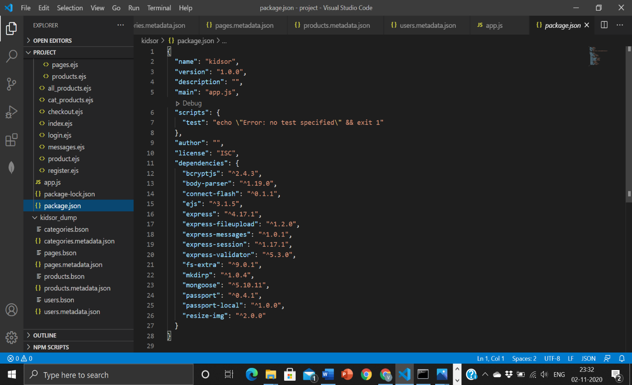

**GITHUB LINK:**

**https://github.com/Sairaj47/shopping-cart**

**OUTPUT:**

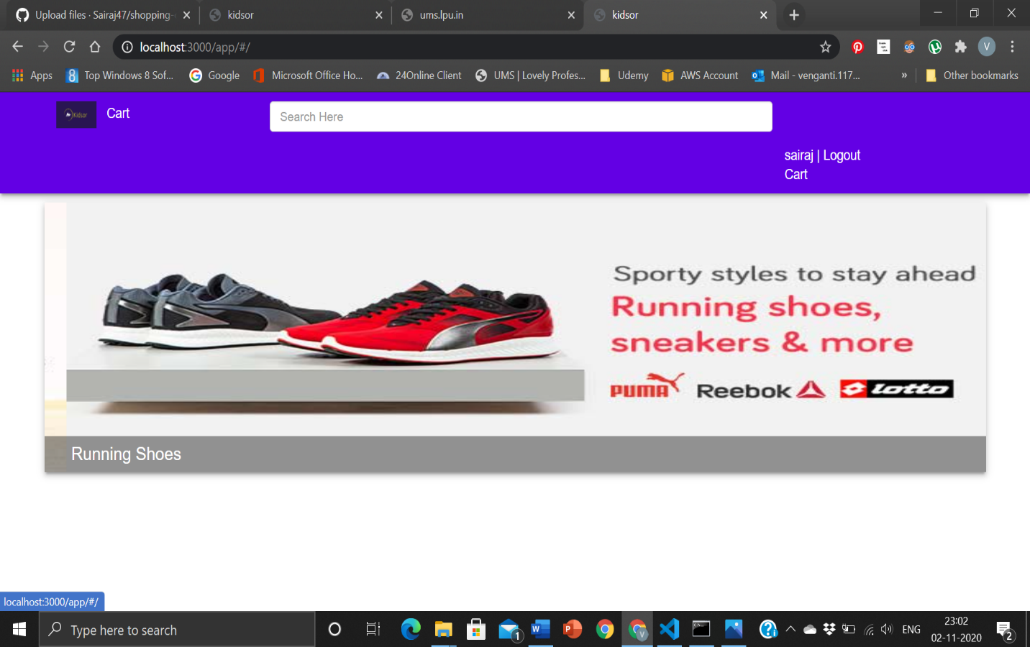

It is the home page of our website.

In this website consumers can directly see the prices of the cars and the cars for rent through online.

At the top we have two buttons Login and Signup

# SIGNIN PAGE

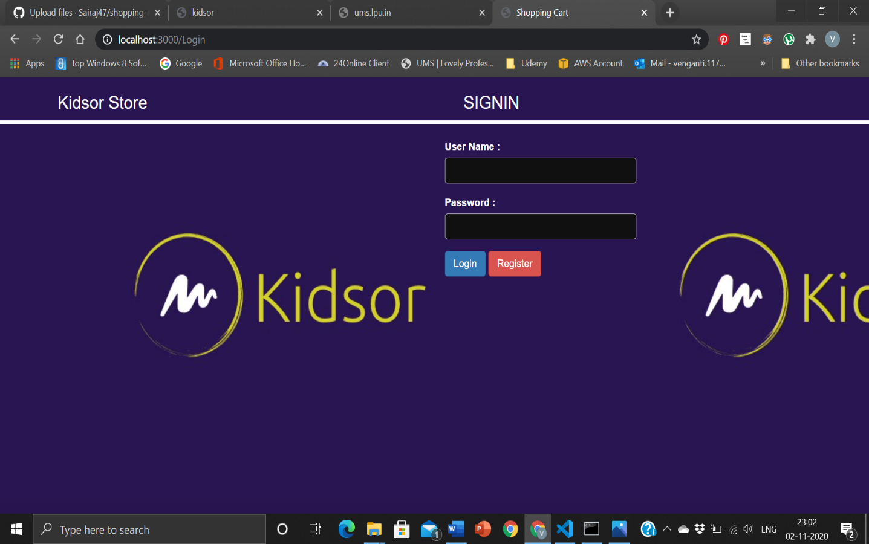

This our website login page.

After went client/ costumer login to the he/she can select the products and the web page looks like after successful login is:

**AFTER LOGIN:**

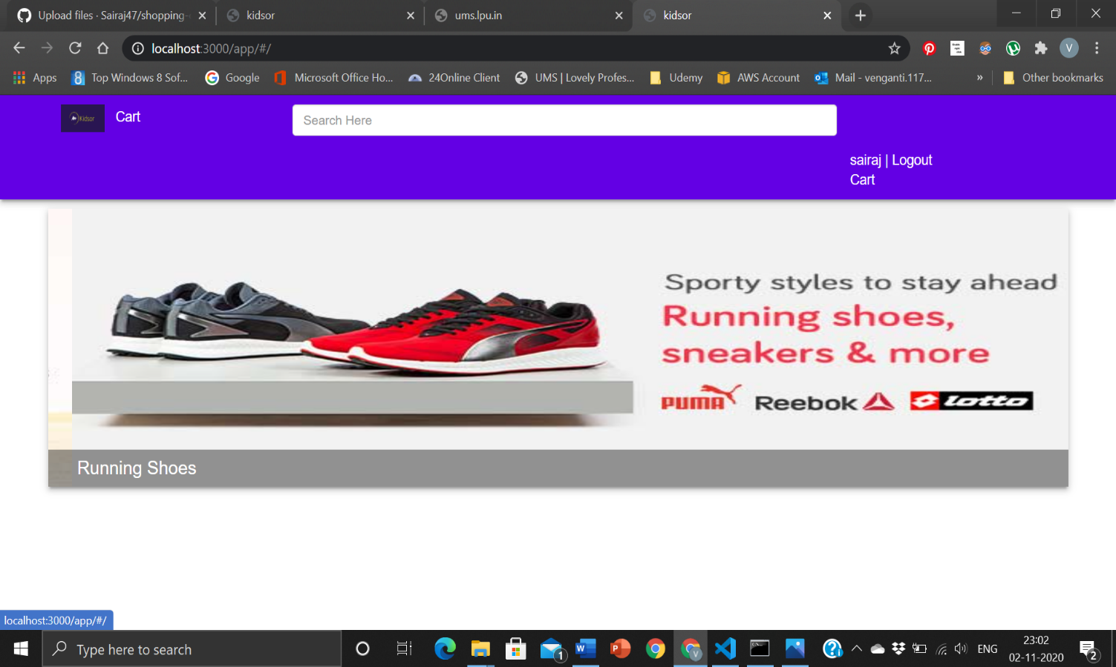

**Cart Status :**

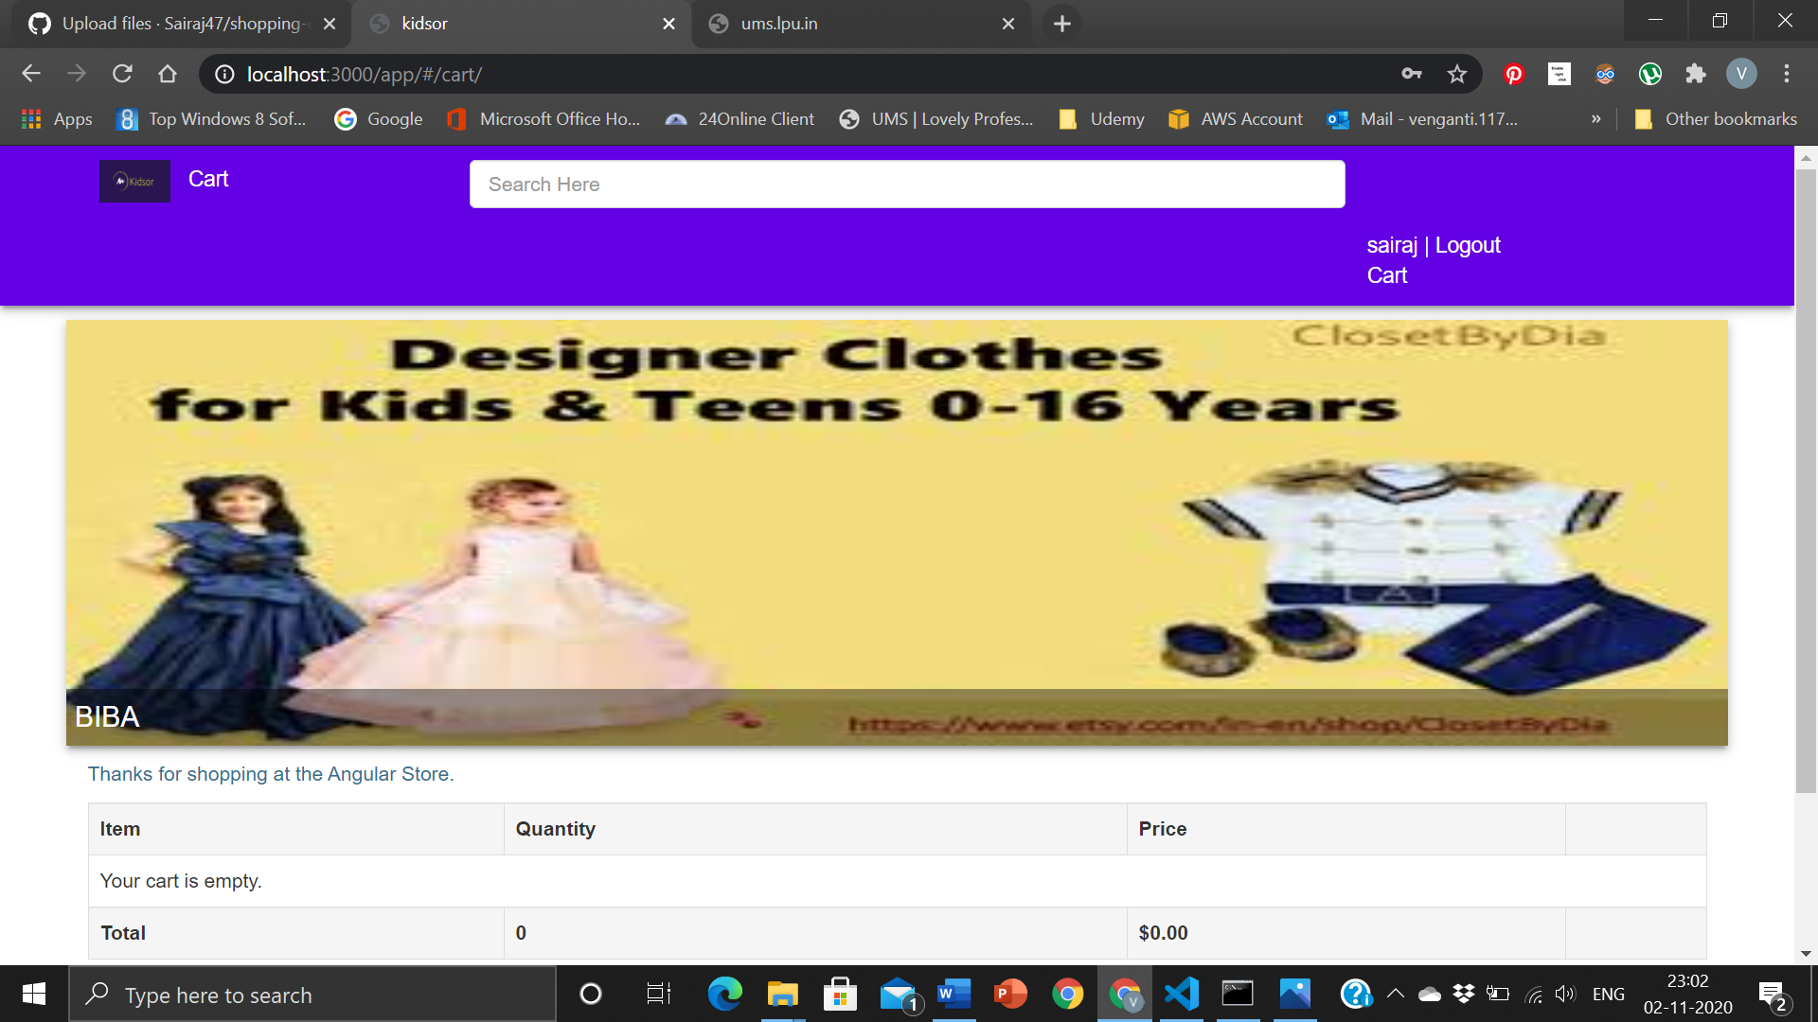

**SIGNUP:**

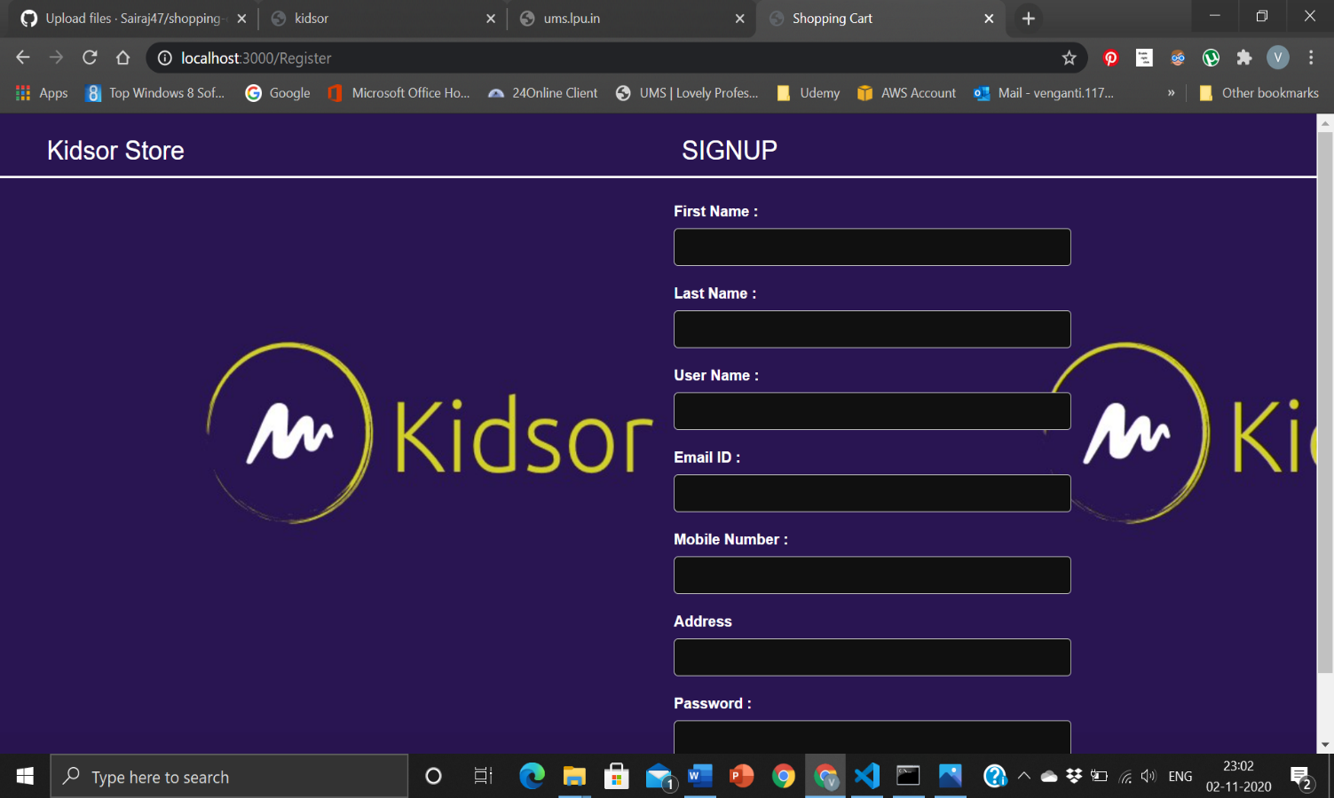

This is the signup page where client can register for the website and take a shopping cart.

**Without Registering:**

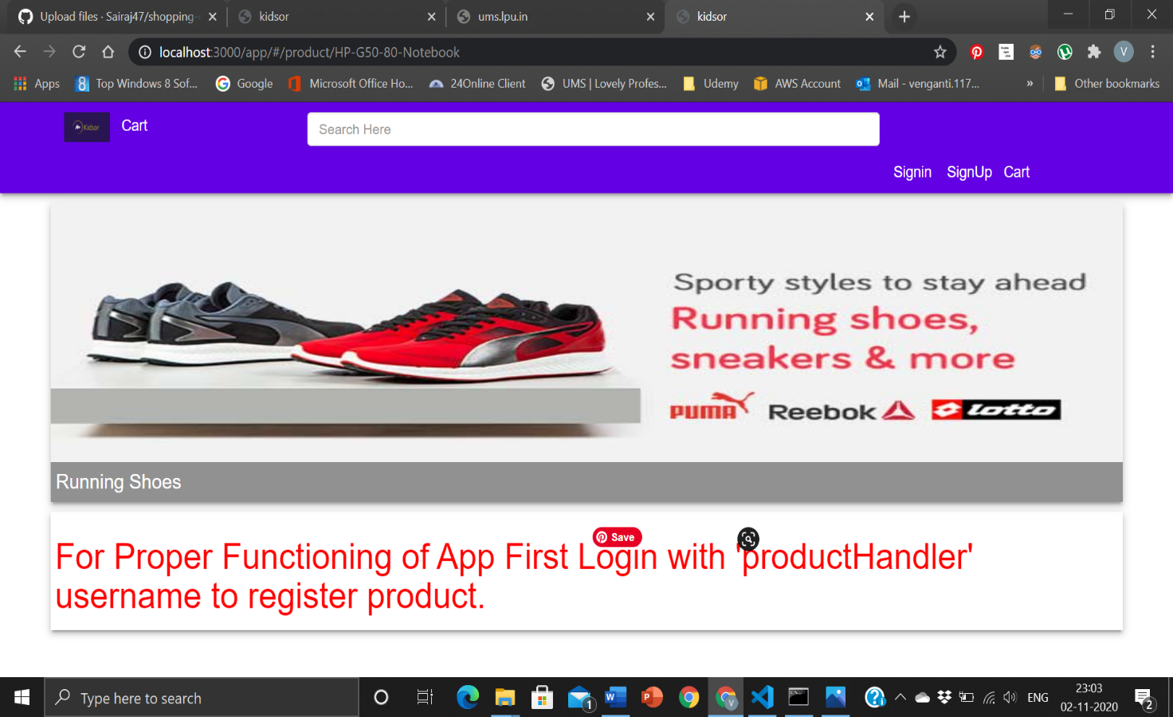

# About

----------------------The End---------------------